Organization: Talosec
Project: Enterprise SOC Virtual Lab
Intern Name: ALI RAYYAN
Mentor: Sir Nasradin
Duration: Month 2 of Internship
Date: 27-01-2026

1. EXECUTIVE SUMMARY
This document provides a comprehensive overview of the Enterprise SOC Virtual
Lab implementation completed during Month 2 of the cybersecurity internship
at Talosec. The lab simulates a real enterprise environment designed for
Security Operations Center (SOC) training, blue team operations, and network
security architecture practice.

The lab environment includes:
• FortiGate firewall for network security and traffic control
• Windows Active Directory infrastructure for centralized authentication
• Windows workstation joined to the domain
• Ubuntu application server for internal services
• Wazuh SIEM for centralized security monitoring and log analysis

This project builds upon Month 1 activities which included Wazuh SIEM
deployment, log analysis, custom detection rule creation, active response
configuration, and honeypot investigation.

2. PROJECT OBJECTIVES

The primary objectives of this lab implementation were:

1. Build and understand enterprise network segmentation
2. Deploy and configure FortiGate firewall architecture
3. Implement centralized authentication using Active Directory
4. Enable endpoint and server monitoring
5. Operate a SOC using Wazuh SIEM
6. Practice blue team detection, logging, and alerting
7. Understand trust boundaries and attack surfaces

Roles Assumed During Implementation:
• Senior Network Architect
• Virtualization Engineer
• SOC Architect
• Cybersecurity Lab Designer

3. LAB ARCHITECTURE OVERVIEW

The lab environment was built using VMware Workstation as the virtualization
platform. The architecture consists of three security zones separated by a
FortiGate firewall, with Wazuh SIEM providing centralized monitoring.

4. NETWORK DESIGN

4.1 Network Topology Diagram

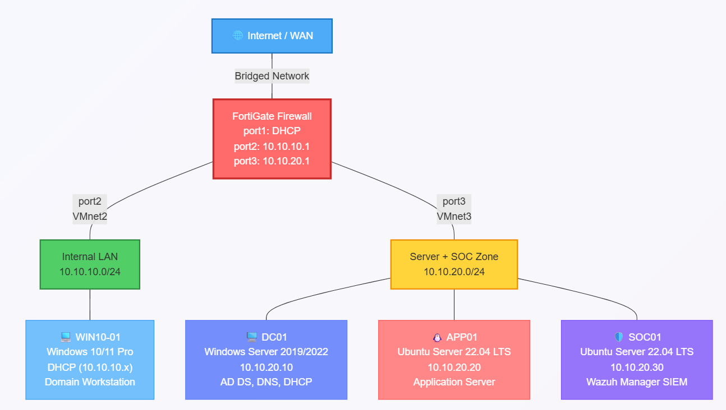

5. VM Resource Allocation:

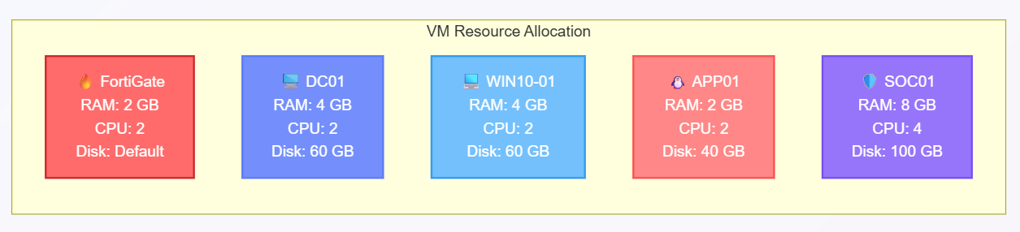└────────────┴────────┴────────────┴───────────┘

6. IMPLEMENTATION STEPS

6.1 VMware Network Configuration
Step 1: Opened VMware Workstation and navigated to Edit → Virtual Network Editor

Step 2: Clicked "Change Settings" to run as Administrator

Step 3: Created the following virtual networks:

VMnet0 (Bridged):
• Type: Bridged
• Bridged to: WiFi Adapter
• Purpose: WAN/Internet connectivity for FortiGate

VMnet2 (Host-only):
• Type: Host-only
• Subnet: 10.10.10.0
• Subnet Mask: 255.255.255.0
• DHCP: Disabled
• Purpose: Internal LAN network

VMnet3 (Host-only):
• Type: Host-only
• Subnet: 10.10.20.0
• Subnet Mask: 255.255.255.0
• DHCP: Disabled
• Purpose: Server + SOC network

Step 4: Applied configuration and closed Virtual Network Editon
6.2 FortiGate Firewall Setup
Step 1: Imported FortiGate VM into VMware Workstation
Step 2: Configured VM hardware settings:
• Memory: 2 GB
• Processors: 2
• Network Adapter 1: VMnet0 (Bridged) - WAN
• Network Adapter 2: VMnet2 - Internal LAN
• Network Adapter 3: VMnet3 - Server + SOC

Step 3: Powered on FortiGate VM and waited for boot completion

Step 4: Logged in with default credentials:
• Username: admin
• Password: (blank)

Step 5: Set new admin password when prompted

Step 6: Configured network interfaces via CLI:

Port 1 (WAN):
─────────────
- config system interface
- edit port1
- set mode dhcp
- set allowaccess ping https ssh http fgfm
- set alias "WAN"
- set role wan
- next
- end

Port 2 (Internal LAN):
──────────────────────
- config system interface
- edit port2
- set mode static
- set ip 10.10.10.1 255.255.255.0
- set allowaccess ping https ssh http
- set alias "Internal-LAN"
- set role lan
- next
- end

Port 3 (Server + SOC):
──────────────────────
- config system interface
- edit port3
- set mode static
- set ip 10.10.20.1 255.255.255.0
- set allowaccess ping https ssh http
- set alias "Server-SOC-Network"
- set role lan
- next
- end

Step 7: Configured DNS:

- config system dns
- set primary 8.8.8.8
- set secondary 8.8.4.4
- end

Step 8: Verified interface configuration:
- get system interface physical
Step 9: Configured DHCP server for Internal LAN:

- config system dhcp server
- edit 1
- set interface "port2"
- set default-gateway 10.10.10.1
- set netmask 255.255.255.0
- set dns-server1 10.10.20.10
- set dns-server2 8.8.8.8
- config ip-range
- edit 1
- set start-ip 10.10.10.100
- set end-ip 10.10.10.200
- next
- end
- next
- end

Step 10: Tested internet connectivity:

- execute ping 8.8.8.8
- execute ping google.com
- Step 11: Configured Syslog to forward logs to Wazuh:

- config log syslogd setting
- set status enable
- set server "10.10.20.30"
- set port 514
- set facility local7
- set format default
- set mode udp
- end

- config log syslogd filter
- set severity information
- set forward-traffic enable
- set local-traffic enable
- set anomaly enable
- end

Step 12: Accessed FortiGate GUI via browser:

- URL: https://[FortiGate-WAN-IP]
- Username: admin
- Password: [configured password]

6.3 Windows Server (DC01) Setup
───────────────────────────────

Step 1: Created new VM in VMware:
• Name: DC01
• Guest OS: Windows Server 2019/2022
• Memory: 4 GB
• Processors: 2
• Disk: 60 GB
• Network: VMnet3

Step 2: Attached Windows Server ISO and started installation

Step 3: Selected "Windows Server 2019/2022 Standard (Desktop Experience)"

Step 4: Completed installation and set Administrator password: Talosec@2024!

Step 5: Configured static IP address:
• IP Address: 10.10.20.10
• Subnet Mask: 255.255.255.0
• Default Gateway: 10.10.20.1
• Preferred DNS: 127.0.0.1
• Alternate DNS: 8.8.8.8

Step 6: Tested network connectivity:

- ping 10.10.20.1
- ping 8.8.8.8

Step 7: Renamed server using PowerShell:

- Rename-Computer -NewName "DC01" -Restart

Step 8: After restart, installed Active Directory Domain Services:

- Install-WindowsFeature -Name AD-Domain-Services -IncludeManagementTools

Step 9: Promoted server to Domain Controller:

- Install-ADDSForest `
- -DomainName "talosec.local" `
- -DomainNetbiosName "TALOSEC" `
- -InstallDns:$true `
- -SafeModeAdministratorPassword (ConvertTo-SecureString "Talosec@Recovery1!" -AsPlainText -Force) `
- -Force:$true
- Server restarted automatically.

Step 10: After restart, verified AD installation:
- Get-ADDomain
- Get-ADForest
- Get-ADDomainController
Step 11: Configured DNS forwarders:

- Add-DnsServerForwarder -IPAddress "8.8.8.8"
- Add-DnsServerForwarder -IPAddress "8.8.4.4"
Step 12: Created Organizational Units:
- New-ADOrganizationalUnit -Name "Talosec-Users" -Path "DC=talosec,DC=local"
- New-ADOrganizationalUnit -Name "Talosec-Computers" -Path "DC=talosec,DC=local"
- New-ADOrganizationalUnit -Name "Talosec-Servers" -Path "DC=talosec,DC=local"
Step 13: Created test users:

# Regular User 1
- New-ADUser -Name "John Smith" `
- -GivenName "John" `
- -Surname "Smith" `
- -SamAccountName "jsmith" `
- -UserPrincipalName "jsmith@talosec.local" `
- -Path "OU=Talosec-Users,DC=talosec,DC=local" `
- -AccountPassword (ConvertTo-SecureString "User@123" -AsPlainText -Force) `
- -PasswordNeverExpires $true `
- -Enabled $true

# Regular User 2
- New-ADUser -Name "Jane Doe" `
- -GivenName "Jane" `
- -Surname "Doe" `
- -SamAccountName "jdoe" `
- -UserPrincipalName "jdoe@talosec.local" `
- -Path "OU=Talosec-Users,DC=talosec,DC=local" `
- -AccountPassword (ConvertTo-SecureString "User@123" -AsPlainText -Force) `
- -PasswordNeverExpires $true `
- -Enabled $true

# SOC Admin User
- New-ADUser -Name "SOC Admin" `
- -GivenName "SOC" `
- -Surname "Admin" `
- -SamAccountName "socadmin" `
- -UserPrincipalName "socadmin@talosec.local" `
- -Path "OU=Talosec-Users,DC=talosec,DC=local" `
- -AccountPassword (ConvertTo-SecureString "SOCAdmin@123" -AsPlainText -Force) `
- -PasswordNeverExpires $true `
- -Enabled $true

# Add SOC Admin to Domain Admins
- Add-ADGroupMember -Identity "Domain Admins" -Members "socadmin"

Step 14: Verified users:
- Get-ADUser -Filter * -SearchBase "OU=Talosec-Users,DC=talosec,DC=local" | Select-Object Name, SamAccountName
Step 15: Enabled advanced audit policies:

- auditpol /set /subcategory:"Logon" /success:enable /failure:enable
- auditpol /set /subcategory:"Logoff" /success:enable
- auditpol /set /subcategory:"Account Lockout" /failure:enable
- auditpol /set /subcategory:"Special Logon" /success:enable
- auditpol /set /subcategory:"User Account Management" /success:enable /failure:enable
- auditpol /set /subcategory:"Security Group Management" /success:enable
- auditpol /set /subcategory:"Process Creation" /success:enable

Step 16: Created snapshot - "DC01-AD-Complete"
6.4 Windows 10/11 Workstation (WIN10-01) Setup

Step 1: Created new VM in VMware:
• Name: WIN10-01
• Guest OS: Windows 10/11 x64
• Memory: 4 GB
• Processors: 2
• Disk: 60 GB
• Network: VMnet2

Step 2: Attached Windows 10/11 Pro ISO and started installation

Step 3: Completed installation with local account:
• Username: localadmin
• Password: Talosec@2024

Step 4: Verified DHCP IP assignment:

- ipconfig /all

Expected output:
• IPv4 Address: 10.10.10.100 (or similar from DHCP range)
• Subnet Mask: 255.255.255.0
• Default Gateway: 10.10.10.1
• DNS Server: 10.10.20.10
Step 5: Tested network connectivity:

ping 10.10.10.1
ping 10.10.20.10
ping 8.8.8.8
nslookup talosec.local

Step 6: Joined domain using PowerShell (Administrator):
- Add-Computer -DomainName "talosec.local" -Credential TALOSEC\Administrator -Restart
- Entered password: Talosec@2024!

Step 7: After restart, tested domain login:
• Username: TALOSEC\jsmith
• Password: User@123
Login successful.
Step 8: Installed Sysmon for enhanced logging:
# Created Sysmon folder
- New-Item -Path "C:\Sysmon" -ItemType Directory -Force
# Downloaded Sysmon
- Invoke-WebRequest -Uri "https://download.sysinternals.com/files/Sysmon.zip" -OutFile "C:\Sysmon\Sysmon.zip"

# Extracted files
- Expand-Archive -Path "C:\Sysmon\Sysmon.zip" -DestinationPath "C:\Sysmon" -Force

# Downloaded SwiftOnSecurity config
- Invoke-WebRequest -Uri "https://raw.githubusercontent.com/SwiftOnSecurity/sysmon-config/master/sysmonconfig-export.xml" -OutFile "C:\Sysmon\sysmonconfig.xml"

# Installed Sysmon with config
- C:\Sysmon\Sysmon64.exe -accepteula -i C:\Sysmon\sysmonconfig.xml

Step 9: Verified Sysmon running:
- Get-Service Sysmon64
6.5 Ubuntu Application Server (APP01) Setup

Step 1: Created new VM in VMware:
• Name: APP01
• Guest OS: Ubuntu 64-bit
• Memory: 2 GB
• Processors: 2
• Disk: 40 GB
• Network: VMnet3
Step 2: Attached Ubuntu Server 22.04 LTS ISO and started installation

Step 3: Completed installation:
• Server name: APP01
• Username: sysadmin
• Password: Talosec@2024
• Enabled OpenSSH server during installation
Step 4: Logged in and configured static IP:
- sudo nano /etc/netplan/00-installer-config.yaml
Content:
network:
version: 2
renderer: networkd
ethernets:
ens33:
addresses:
- 10.10.20.20/24
routes:
- to: default
via: 10.10.20.1
nameservers:
addresses:
- 10.10.20.10
- 8.8.8.8
search:
- talosec.local
Step 5: Applied network configuration:
- sudo netplan apply
Step 6: Verified network configuration:

- ip addr show
- ping 10.10.20.1
- ping 8.8.8.8
Step 7: Set hostname:

- sudo hostnamectl set-hostname APP01

Step 8: Updated system:

- sudo apt update && sudo apt upgrade -y

Step 9: Installed Apache web server:

- sudo apt install apache2 -y
- sudo systemctl enable apache2
- sudo systemctl start apache2

Step 10: Created test web page:

sudo bash -c 'cat > /var/www/html/index.html << EOF
<!DOCTYPE html>
<html>
<head>
<title>Talosec Internal Server</title>
</head>
<body>
<h1>Welcome to Talosec Internal Application Server</h1>
<p>Server: APP01</p>
<p>IP: 10.10.20.20</p>
</body>
</html>
EOF'

Step 11: Verified Apache running:

- sudo systemctl status apache2
- curl http://localhost

Step 12: Installed audit daemon:

- sudo apt install auditd audispd-plugins -y
- sudo systemctl enable auditd
- sudo systemctl start auditd

Step 13: Created snapshot - "APP01-Configured"

6.6 Wazuh Manager (SOC01) Setup

Step 1: Created new VM in VMware:
• Name: SOC01
• Guest OS: Ubuntu 64-bit
• Memory: 8 GB (Important for Wazuh)
• Processors: 4
• Disk: 100 GB
• Network: VMnet3

Step 2: Attached Ubuntu Server 22.04 LTS ISO and started installation

Step 3: Completed installation:
• Server name: SOC01
• Username: socadmin
• Password: Talosec@2024
• Enabled OpenSSH server during installation

Step 4: Logged in and configured static IP:

sudo nano /etc/netplan/00-installer-config.yaml

Content:
network:
version: 2
renderer: networkd
ethernets:
ens33:
addresses:
- 10.10.20.30/24
routes:
- to: default
via: 10.10.20.1
nameservers:
addresses:
- 10.10.20.10
- 8.8.8.8
search:
- talosec.local

Step 5: Applied network configuration:

sudo netplan apply

Step 6: Verified connectivity:

- ip addr show
- ping 10.10.20.1
- ping 10.10.20.10
- ping 8.8.8.8

Step 7: Set hostname:

- sudo hostnamectl set-hostname SOC01

Step 8: Updated system:

sudo apt update && sudo apt upgrade -y

Step 9: Installed Wazuh (All-in-One installation):

- curl -sO https://packages.wazuh.com/4.7/wazuh-install.sh
- sudo bash wazuh-install.sh -a

Installation took approximately 15-20 minutes.

Step 10: Saved admin password displayed at end of installation

Note: Password was saved from installation output for dashboard access.

Step 11: Verified Wazuh services:

- sudo systemctl status wazuh-manager
- sudo systemctl status wazuh-indexer
- sudo systemctl status wazuh-dashboard

All three services showed "active (running)" status.
Step 12: Accessed Wazuh Dashboard:

URL: https://10.10.20.30
Username: admin
Password: [password from installation]

Accepted certificate warning and logged in successfully.
Step 13: Configured Wazuh to receive syslog from FortiGate:

sudo nano /var/ossec/etc/ossec.conf

Added the following within <ossec_config>:
<remote>
<connection>syslog</connection>
<port>514</port>
<protocol>udp</protocol>
<allowed-ips>10.10.20.1</allowed-ips>
</remote>

Step 14: Restarted Wazuh Manager:

sudo systemctl restart wazuh-manager

6.7 Wazuh Agent Deployment

6.7.1 Agent on DC01 (Windows Server)

Step 1: In Wazuh Dashboard, navigated to Agents → Deploy new agent

Step 2: Selected:
• Operating System: Windows
• Server address: 10.10.20.30
• Agent name: DC01

Step 3: On DC01, opened PowerShell as Administrator and ran:

Invoke-WebRequest -Uri https://packages.wazuh.com/4.x/windows/wazuh-agent-4.7.0-1.msi -OutFile ${env:tmp}\wazuh-agent.msi; msiexec.exe /i ${env:tmp}\wazuh-agent.msi /q WAZUH_MANAGER='10.10.20.30' WAZUH_AGENT_NAME='DC01' WAZUH_REGISTRATION_SERVER='10.10.20.30'

Step 4: Started the agent service:

NET START Wazuh

Step 5: Verified agent running:
Get-Service Wazuh

6.7.2 Agent on WIN10-01 (Windows Workstation)

Step 1: On WIN10-01, opened PowerShell as Administrator and ran:

Invoke-WebRequest -Uri https://packages.wazuh.com/4.x/windows/wazuh-agent-4.7.0-1.msi -OutFile ${env:tmp}\wazuh-agent.msi; msiexec.exe /i ${env:tmp}\wazuh-agent.msi /q WAZUH_MANAGER='10.10.20.30' WAZUH_AGENT_NAME='WIN10-01' WAZUH_REGISTRATION_SERVER='10.10.20.30'

Step 2: Started the agent service:

NET START Wazuh

Step 3: Verified agent running:

Get-Service Wazuh
6.7.3 Agent on APP01 (Ubuntu Server)
Step 1: Added Wazuh repository:
curl -s https://packages.wazuh.com/key/GPG-KEY-WAZUH | gpg --no-default-keyring --keyring gnupg-ring:/usr/share/keyrings/wazuh.gpg --import && chmod 644 /usr/share/keyrings/wazuh.gpg

echo "deb [signed-by=/usr/share/keyrings/wazuh.gpg] https://packages.wazuh.com/4.x/apt/ stable main" | sudo tee -a /etc/apt/sources.list.d/wazuh.list

sudo apt update

Step 2: Installed agent:

- sudo WAZUH_MANAGER='10.10.20.30' WAZUH_AGENT_NAME='APP01' apt install wazuh-agent -y

Step 3: Enabled and started agent:
- sudo systemctl daemon-reload
- sudo systemctl enable wazuh-agent
- sudo systemctl start wazuh-agent
Step 4: Verified agent running:
- sudo systemctl status wazuh-agent
6.7.4 Verified All Agents in Wazuh Dashboard

Navigated to Wazuh Dashboard → Agents and verified all three agents showing "Active" status:
• DC01 - Active
• WIN10-01 - Active
• APP01 - Active

7. FIREWALL POLICIES

Three firewall policies were created on FortiGate to control traffic between zones:

7.1 Policy Summary

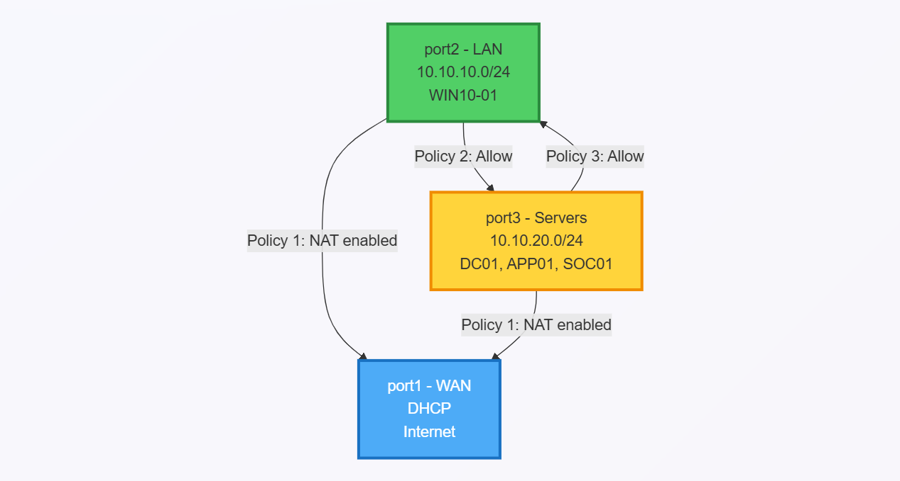7.2 Policy Configurations

Policy 1: All-to-Internet

Purpose: Allows all internal networks to access the internet

- config firewall policy
- edit 1
- set name "All-to-Internet"
- set srcintf "port2" "port3"
- set dstintf "port1"
- set srcaddr "all"
- set dstaddr "all"
- set action accept
- set schedule "always"
- set service "ALL"
- set nat enable
- set logtraffic all
- next
- end

Policy 2: LAN-to-Servers
Purpose: Allows workstations to access servers and SIEM

- config firewall policy
- edit 2
- set name "LAN-to-Servers"
- set srcintf "port2"
- set dstintf "port3"
- set srcaddr "all"
- set dstaddr "all"
- set action accept
- set schedule "always"
- set service "ALL"
- set logtraffic all
- next
- end

Policy 3: Servers-to-LAN
Purpose: Allows servers to respond to LAN (required for DHCP, DNS responses)

- config firewall policy
- edit 3
- set name "Servers-to-LAN"
- set srcintf "port3"
- set dstintf "port2"
- set srcaddr "all"
- set dstaddr "all"
- set action accept
- set schedule "always"
- set service "ALL"
- set logtraffic all
- next
- end

7.3 Traffic Flow Diagram
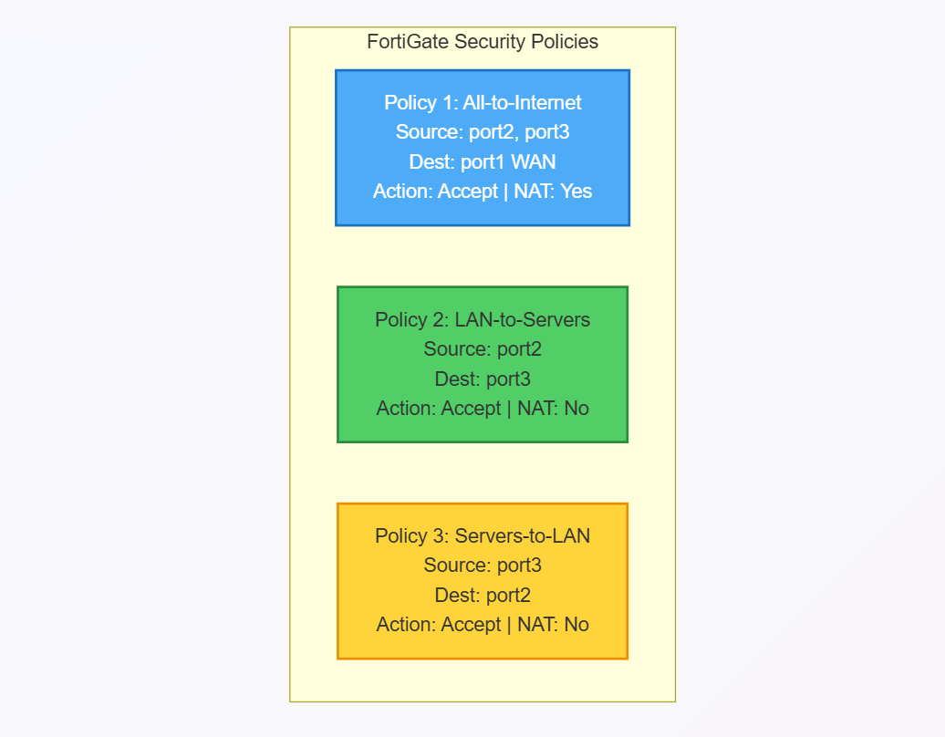

8. TESTING AND VALIDATION

8.1 Network Connectivity Tests

Test 1: WIN10-01 to FortiGate Gateway
Command: ping 10.10.10.1
Result: Success - 4 packets sent, 4 received

Test 2: WIN10-01 to DC01
Command: ping 10.10.20.10
Result: Success - 4 packets sent, 4 received

Test 3: WIN10-01 to Internet
Command: ping 8.8.8.8
Result: Success - 4 packets sent, 4 received

Test 4: WIN10-01 DNS Resolution
Command: nslookup talosec.local
Result: Success - Resolved to 10.10.20.10

Test 5: DC01 to FortiGate Gateway
Command: ping 10.10.20.1
Result: Success - 4 packets sent, 4 received

Test 6: DC01 to Internet
Command: ping 8.8.8.8
Result: Success - 4 packets sent, 4 received

[Screenshot: Connectivity Test Results]

8.2 Security Event Testing

8.2.1 Failed Login Attempts Test

Objective: Generate failed login attempts and verify detection in Wazuh SIEM

Step 1: On WIN10-01, logged out of current session

Step 2: Attempted login with incorrect password:
• Username: TALOSEC\jsmith
• Password: WrongPassword123 (incorrect)

Step 3: Repeated failed login attempt 5 times

Step 4: Verified in Wazuh Dashboard:
• Navigated to Security Events
• Filtered by agent: WIN10-01
• Found alerts for "Authentication failure" (Rule ID: 60122)
Detection Details:
• Rule ID: 60122
• Rule Description: Windows logon failure
• MITRE ATT&CK: T1110 - Brute Force
• Agent: WIN10-01
• Number of Alerts: 5

8.2.2 Successful Login Test
───────────────────────────

Objective: Verify successful login is logged and visible in Wazuh

Step 1: On WIN10-01, logged in with correct credentials:
• Username: TALOSEC\jsmith
• Password: User@123

Step 2: Login was successful

Step 3: Verified in Wazuh Dashboard:
• Navigated to Security Events
• Filtered by agent: WIN10-01
• Found event for "Successful logon" (Rule ID: 60101)
Detection Details:
• Rule ID: 60101
• Rule Description: Windows logon success
• Agent: WIN10-01
• Logon Type: Interactive

8.3 Test Summary
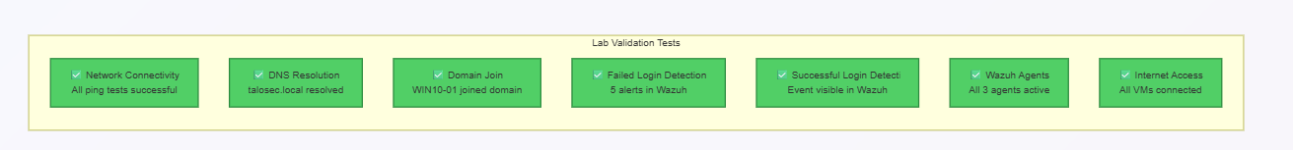

9. CONCLUSION

The Enterprise SOC Virtual Lab was successfully implemented, providing a comprehensive environment for cybersecurity training and blue team operations. The lab demonstrates:

Key Accomplishments:
• Successfully deployed multi-zone network architecture with FortiGate firewall
• Implemented Windows Active Directory infrastructure for centralized authentication
• Deployed Wazuh SIEM with agents across all endpoints
• Created and tested firewall policies for traffic control
• Validated security monitoring through failed and successful login detection
• Established end-to-end logging pipeline from endpoints to SIEM

Skills Developed:
• Network segmentation and security zone design
• FortiGate firewall configuration and policy management
• Windows Server administration and Active Directory
• SIEM deployment and agent management
• Security event analysis and investigation
• Virtualization and lab environment design
• Troubleshooting network connectivity issues

This lab provides a solid foundation for:
• SOC Analyst training
• Blue team exercises
• Security architecture understanding
• Incident detection and response practice

The experience gained from building this environment, including troubleshooting various networking and configuration challenges, has significantly enhanced practical cybersecurity skills applicable to real-world enterprise environments.

10. REFERENCES

• FortiGate Administration Guide
https://docs.fortinet.com/

• Wazuh Documentation
https://documentation.wazuh.com/

• Microsoft Active Directory Documentation
https://docs.microsoft.com/en-us/windows-server/identity/ad-ds/

• VMware Workstation Documentation
https://docs.vmware.com/en/VMware-Workstation-Pro/

• Sysmon Configuration by SwiftOnSecurity
https://github.com/SwiftOnSecurity/sysmon-config

Appendix A: Quick Reference - IP Addresses
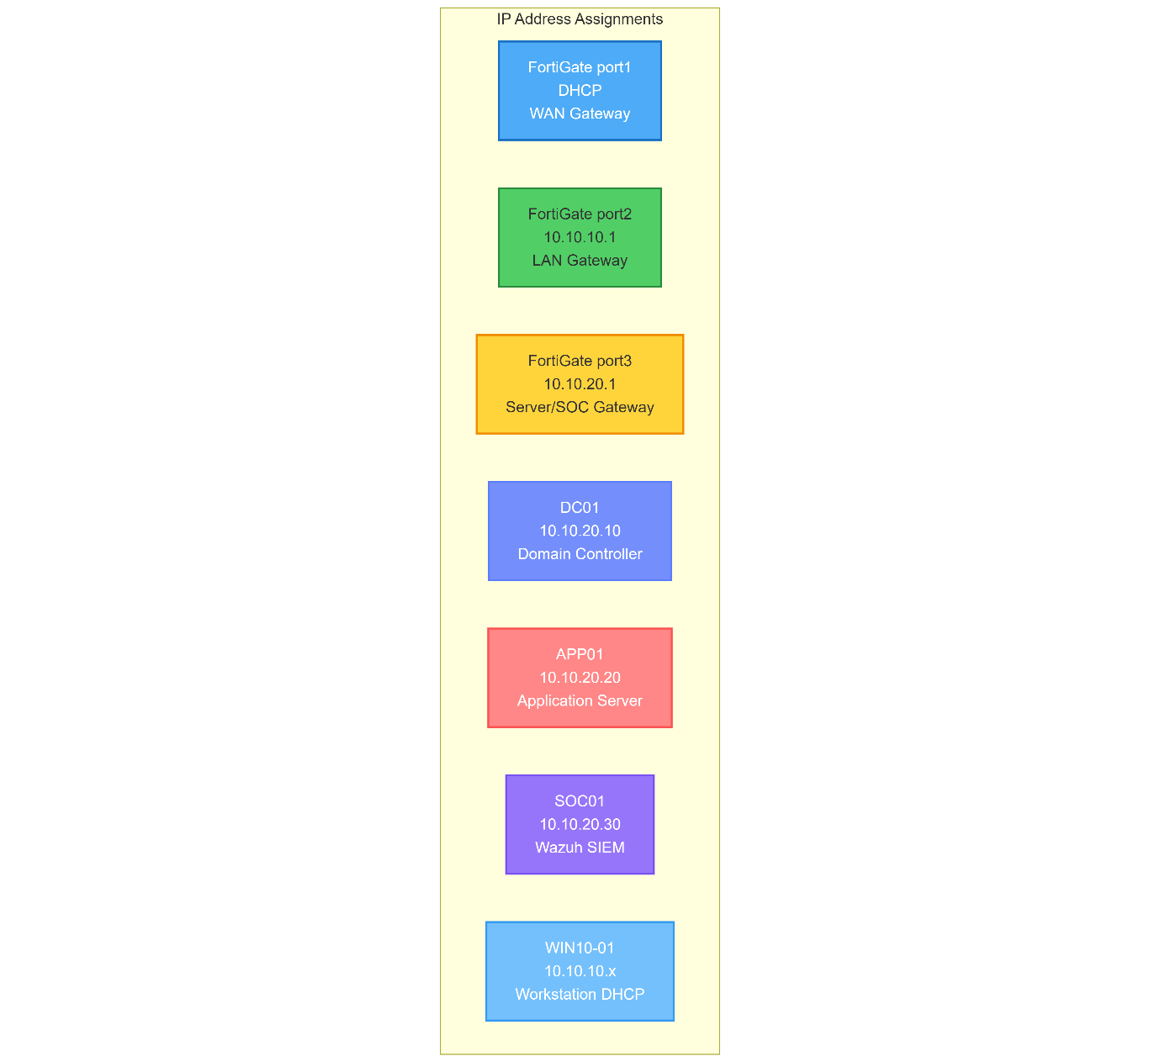

Appendix B: Quick Reference - Credentials
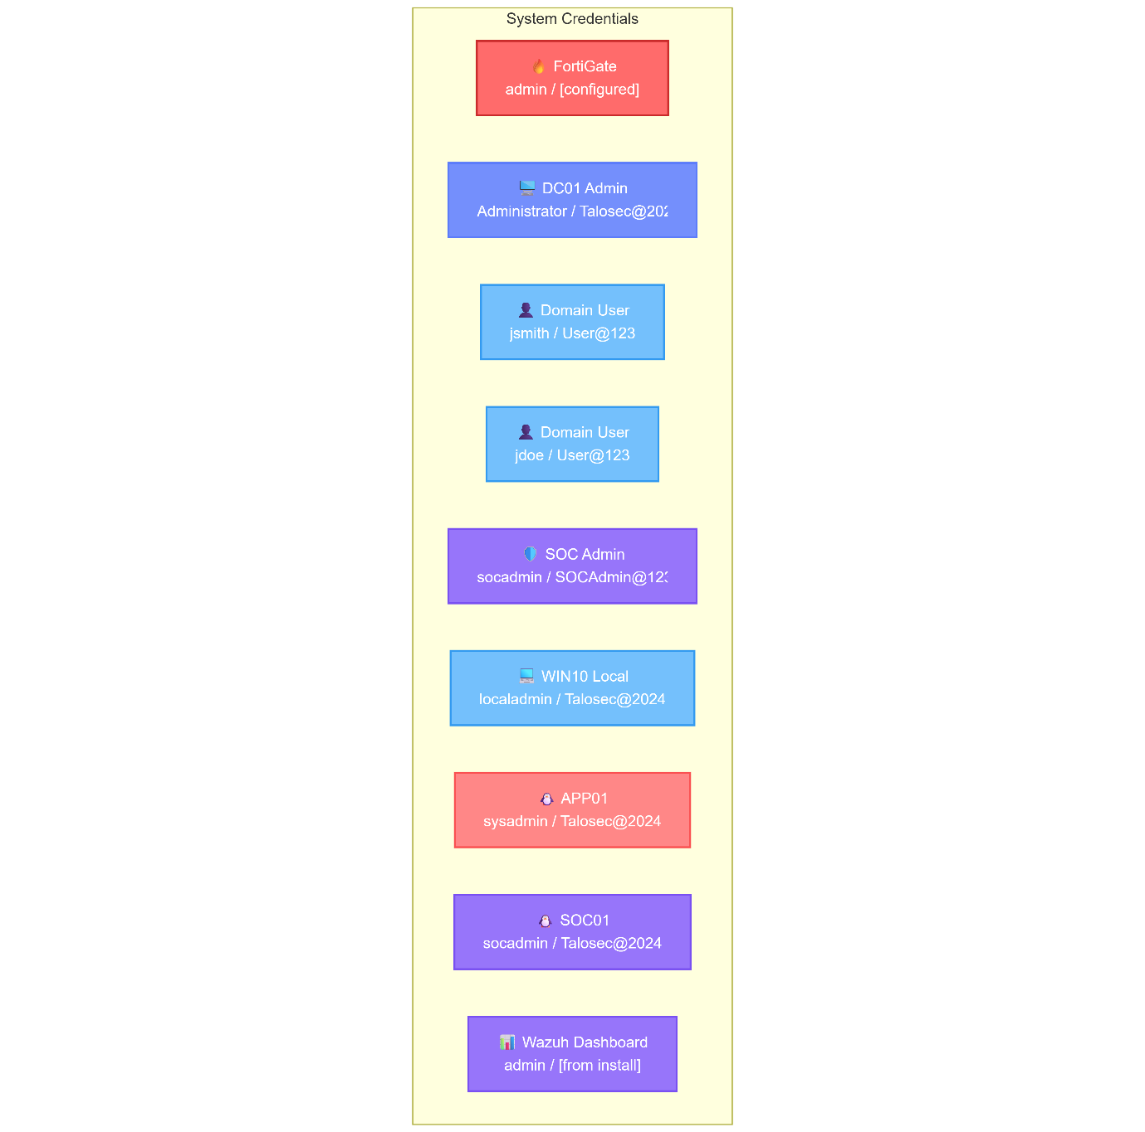
Document Prepared By: Ali Rayyan
Date: 27-01-2026
Internship Program: Talosec Cybersecurity Internship
Mentor: Sir Nasradin
